Preorder Form for Off-Campus Staff
(Credit Card Orders via VENMO or alumni.msstate.edu/staffcouncil)
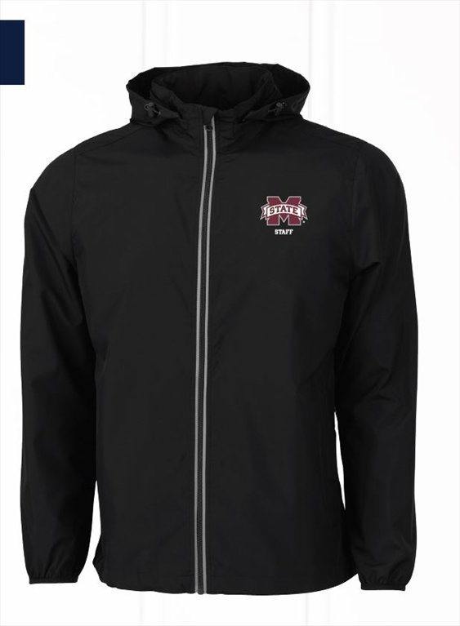

Small – 3XL = $35 each
Size 4XL: kelly.lasalle@msstate.edu for availability

Pre-orders available for Departmental Transfers AND the following:
- County Extension Offices
- Animal & Dairy Sci Farm Workers
- Meridian Campus
- Stennis Space Center
- Vet School
- Research and Extension Centers

Send this form AND payment to: Kelly LaSalle, Mailstop 9634
**Checks payable to MSU Foundation – Please NO CASH!**

** Jackets will NOT be reserved or released until payment or copy of Foundation Request has been received **

PICKUP and SHIPPING options:
One | Location | Contact | Phone | Email
 | Sale Pickup – Nov 1 OR Nov 15 (circle one) | Kelly LaSalle | 662-325-0664 | kelly.lasalle@msstate.edu
 | Meridian - MSU-Riley Center | Suzanne Parker | 601-484-0156 | sparker@meridian.msstate.edu
 | N. Farm - Research Support Units | Jan High | 662-325-8199 | JHigh@mafes.msstate.edu
 | Annual Extension Conference – Bost Breezeway: Oct 30, 11:00-1:00 | Kelly LaSalle | 662-325-0664 | Kelly.lasalle@msstate.edu
 | Shipping: $8 - 1-3 Jackets, $12 - 4+ Jackets | Kelly LaSalle | 662-325-0664 | Kelly.lasalle@msstate.edu

Order Information:
SIZE | QTY |  | SIZE | QTY
Small |  |  | 2X-Large
Medium |  |  | 3X-Large
Large |  |  | 4X - email for availability  kelly.lasalle@msstate.edu
X-Large
Name: _______________________________________ Phone Number: _______________________________
E-mail: _______________________________________
Total Enclosed: ___________

Office Shipping Address (if applicable): _________________________________________________________________________________

